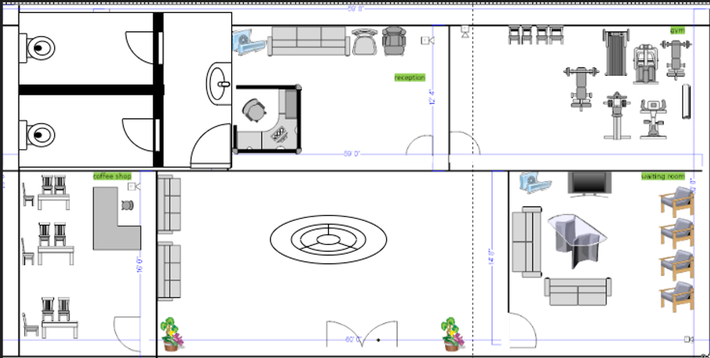

Justification of floor plan:

The initial level of this building encompasses five distinct areas: a guest waiting section, a coffee

shop, a gym, and restroom facilities. It also includes a waiting zone designed for clients and visitors,

with the coffee shop serving as a relaxation area for the staff. Furthermore, the reception desk,

positioned on this floor, plays a crucial role as the central point of communication between the

business and its clients.

To streamline operations effectively, a range of devices such as personal computers, closed-circuit

television (CCTV) systems, printers, and internet-connected phones are deployed throughout the

workspace. These devices are interconnected through a switch, which is then connected to the main

router on the floor via voice-over-internet-phone (VOIP) technology, enabling seamless

communication with the second level.